**Mazen Al Hakim**

**GUI Frames and Their aims**

The project contains many frames that help the user in his/her daily work, and we will specify them in this report.

1. Password Frame:

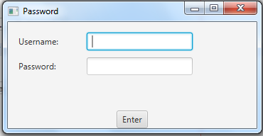

This is the first frame to appear in the P.O.S. where the user should enter the specified username and password then press enter, and if the username and password are correct then the P.O.S. will open, else it will oblige the user to re-enter them.

1. MainPage_Purchase Frame:

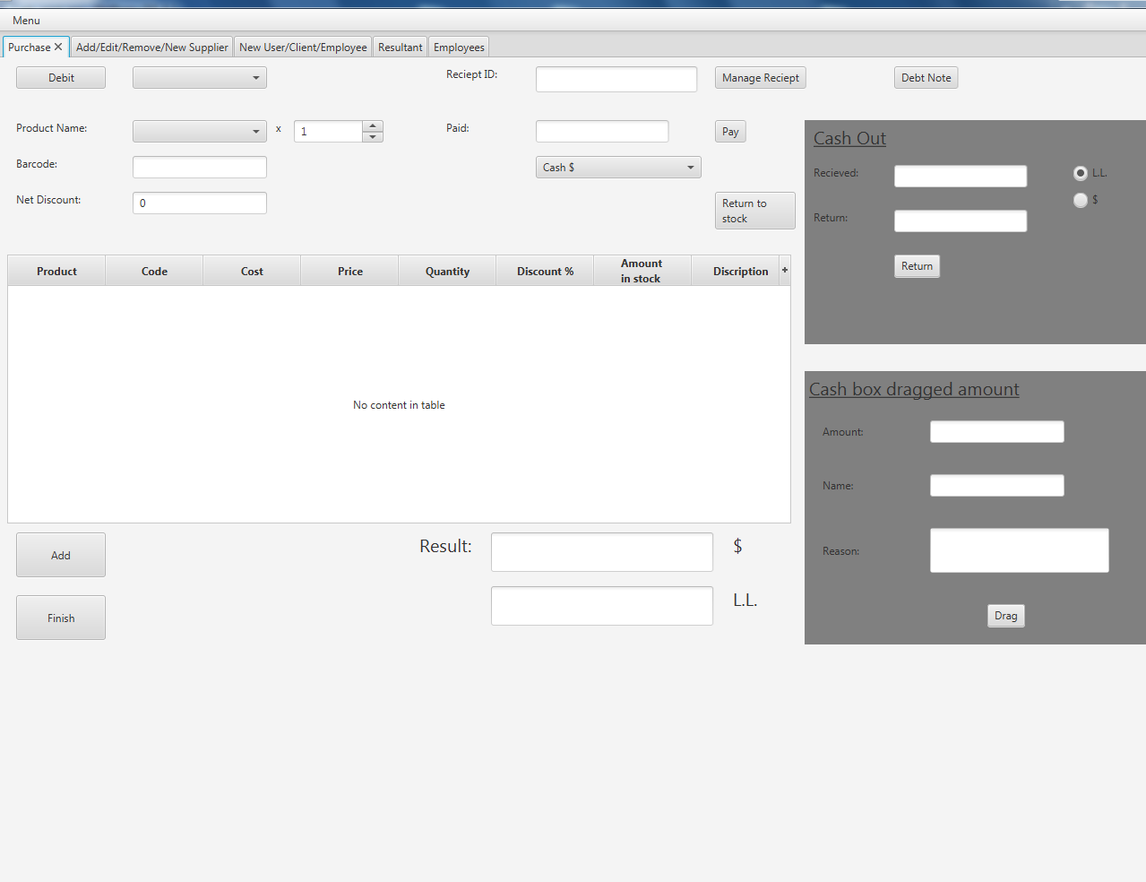

This is the frame used by the user (mainly cashier) to sell the products, where he/she can specify the product he/she needs by its name or barcode with the quantity needed, add overall discount to the receipt, also down payment with many payment options.

The frame also helps the user to know how much he/she should return to the buyer in case the buyer gives him/her money more than the receipt cost.

In addition to that, the frame has a pane that allow the user to save how much he/she dragged from the cashbox if needed for later accounting.

1. Manage Receipt Frame:

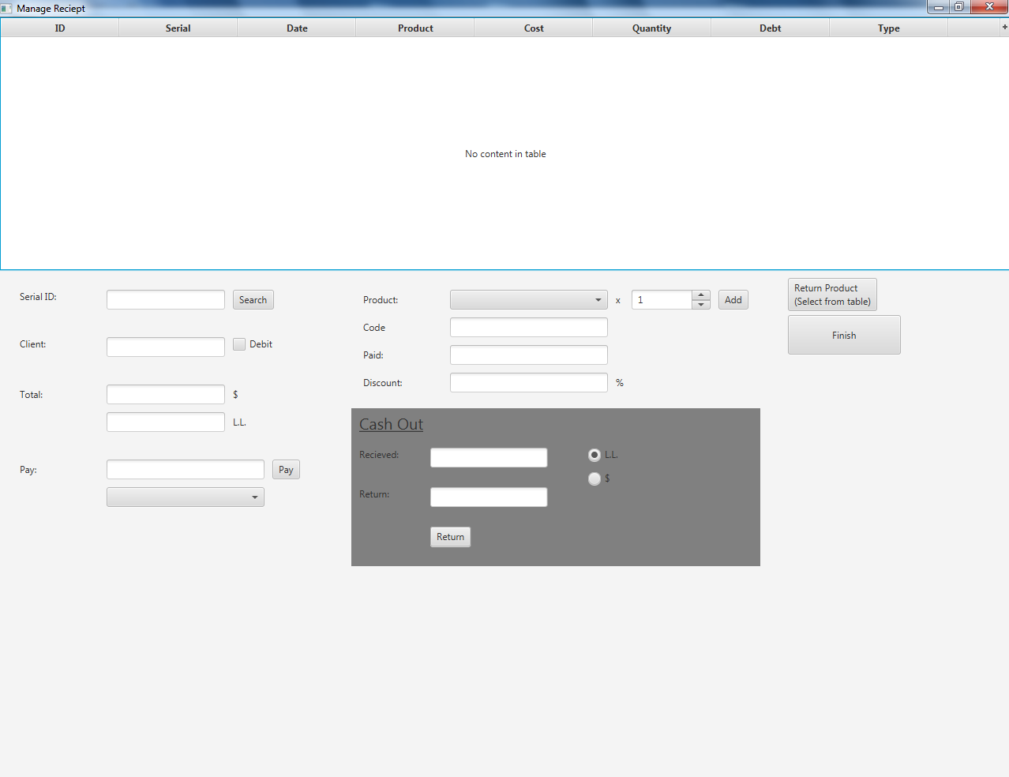

It is a subframe that can be open from the “Manage Receipt” Button from the Purchase frame. It is used to manage a specific receipt by searching its serial number, so the user can add or remove products or payments to it, in addition to the same Cash Out pain that helps the user to calculate the money he/she should return to the client if needed.

1. Debit Note Frame:

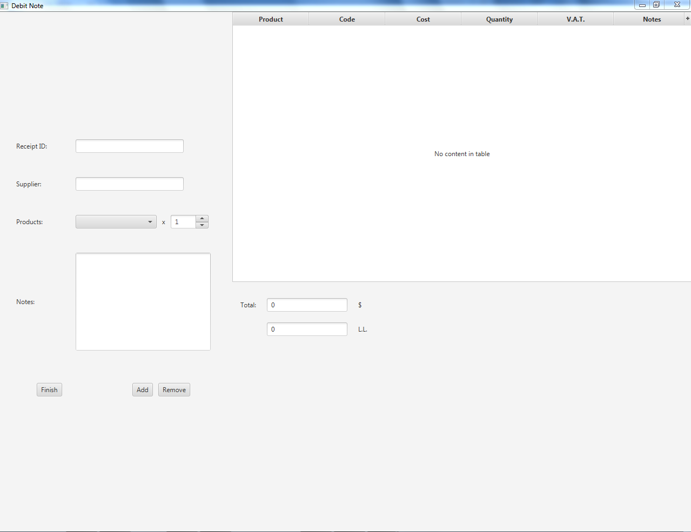

It is a subframe that can be open from the “Debit Note” Button from the Purchase frame.

It allows the user to return products to the supplier after he/she already bought it, where the product is searched by name and added to a receipt specific for returning to supplier.

1. Product and Suppliers Settings Frame:

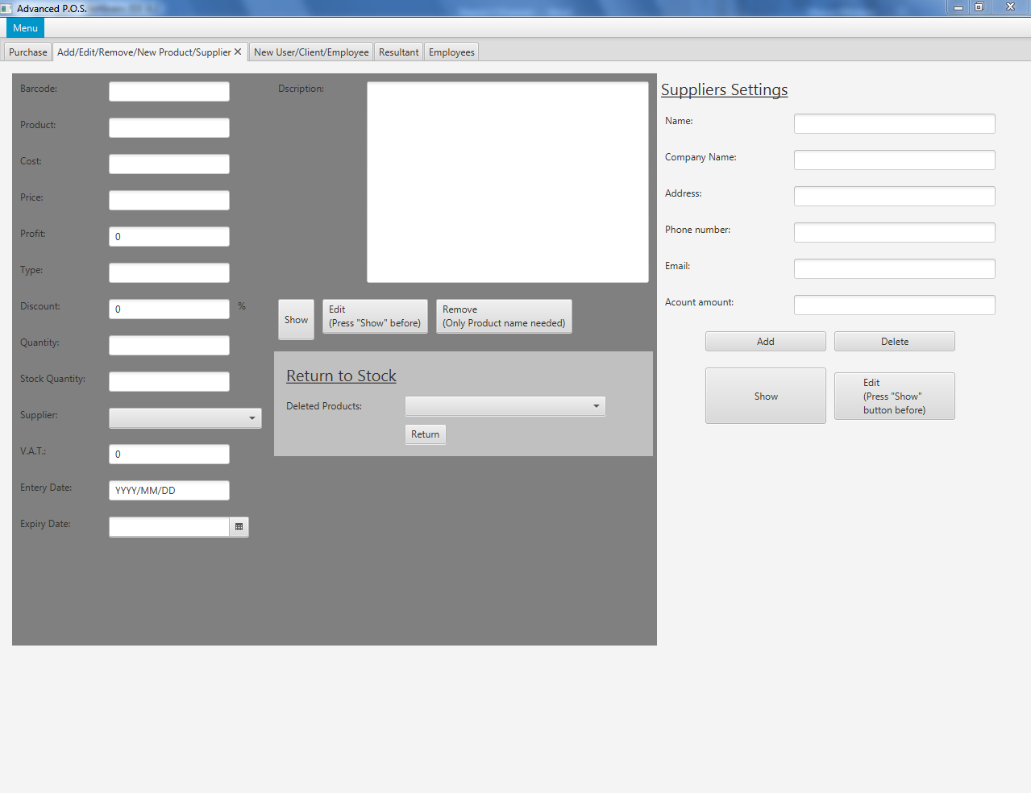

This Frame is used to enter all the information needed for the products or suppliers to be saved in the database. The settings can be also edited after shown, or also the product or supplier can be removed at all.

1. Users, Clients, and Employees Settings Frame:

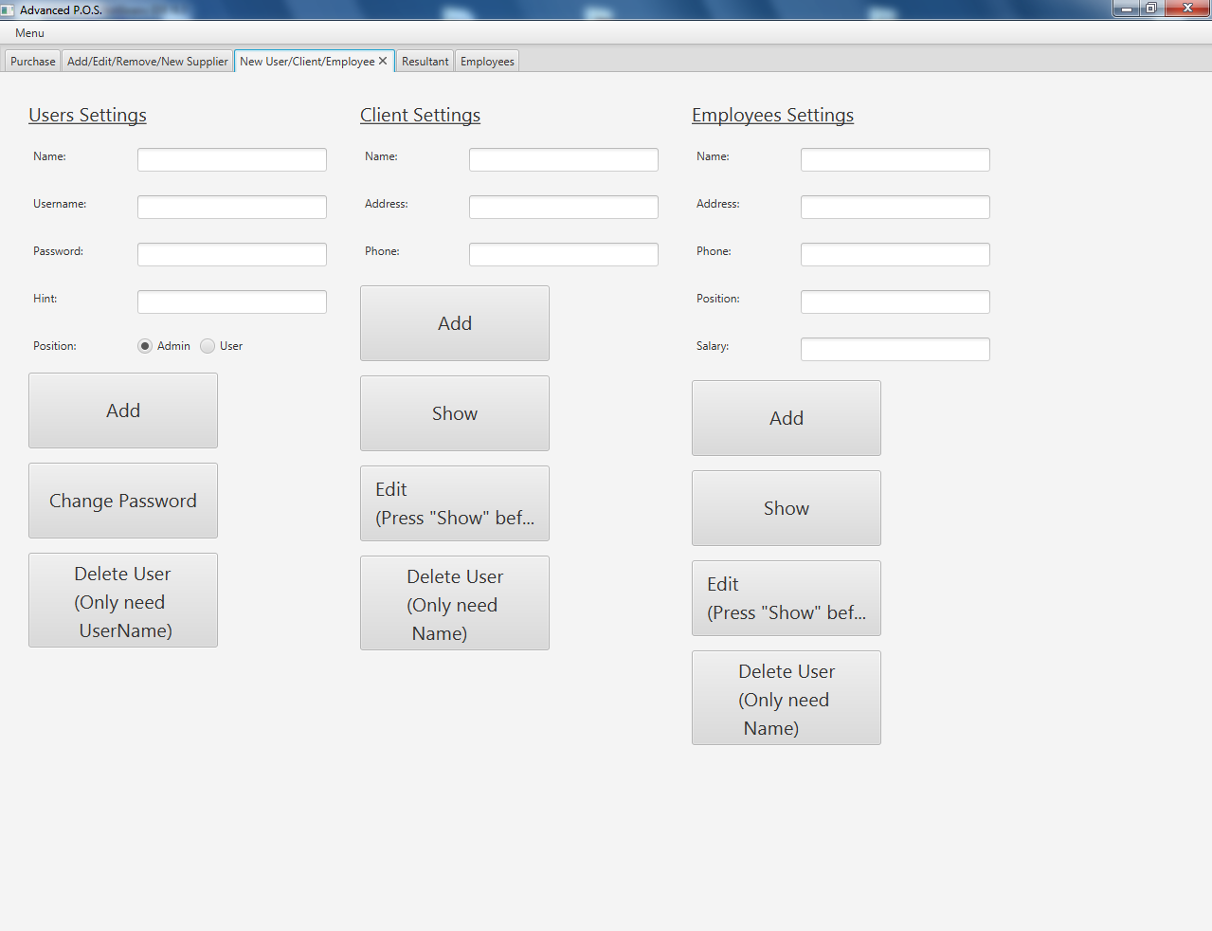

This Frame is used to enter all the information needed for the users, clients and employees to be saved in the database. The settings can be also edited after shown, or also the any of the specified above can be removed at all.

1. Employees Payments Frame:

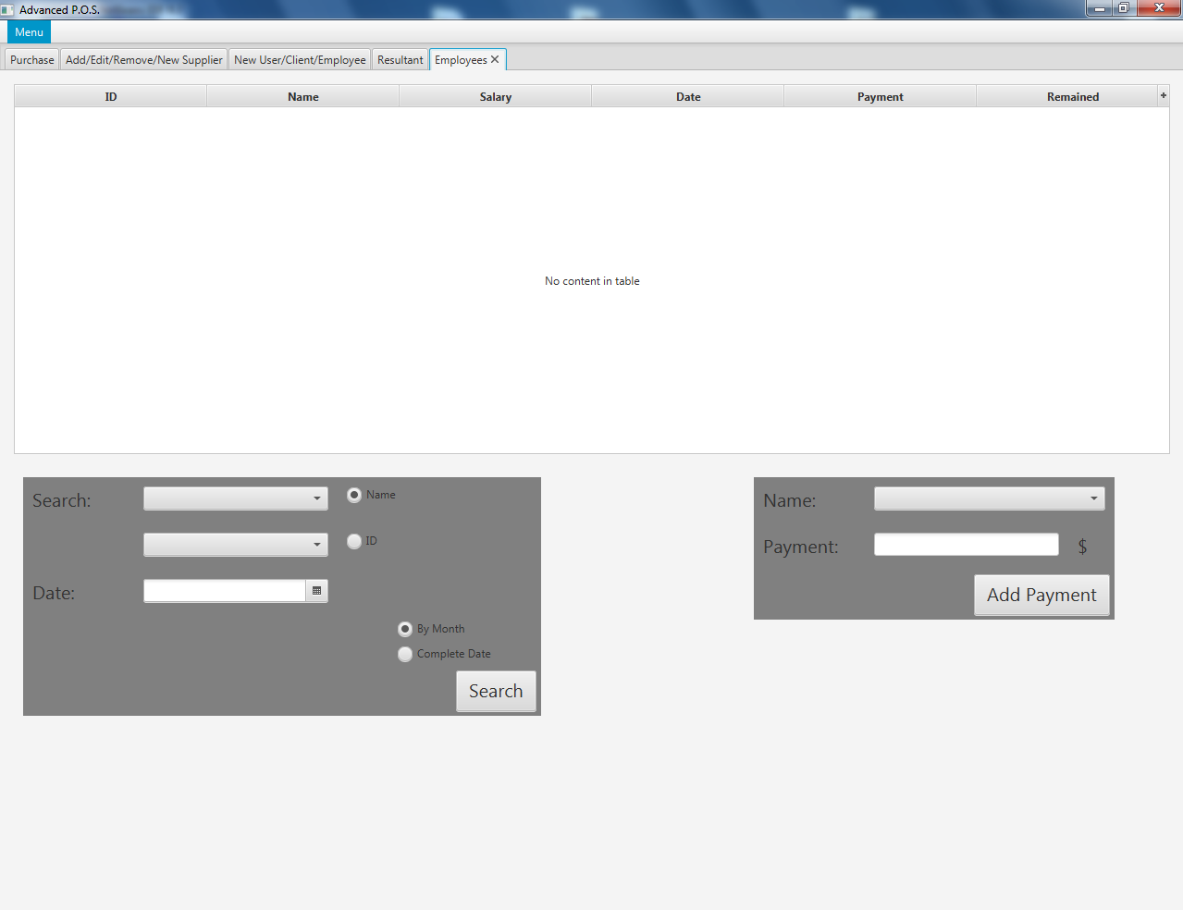

This frame is used to add and search employees’ payments.

1. Resultant frame:

It is used to show the results of the user’s business, and is consists of three tabs each one with specific aim:

* 1. Stock tab
  2. Daily Sale tab
  3. Clients tab

1. Stock tab:

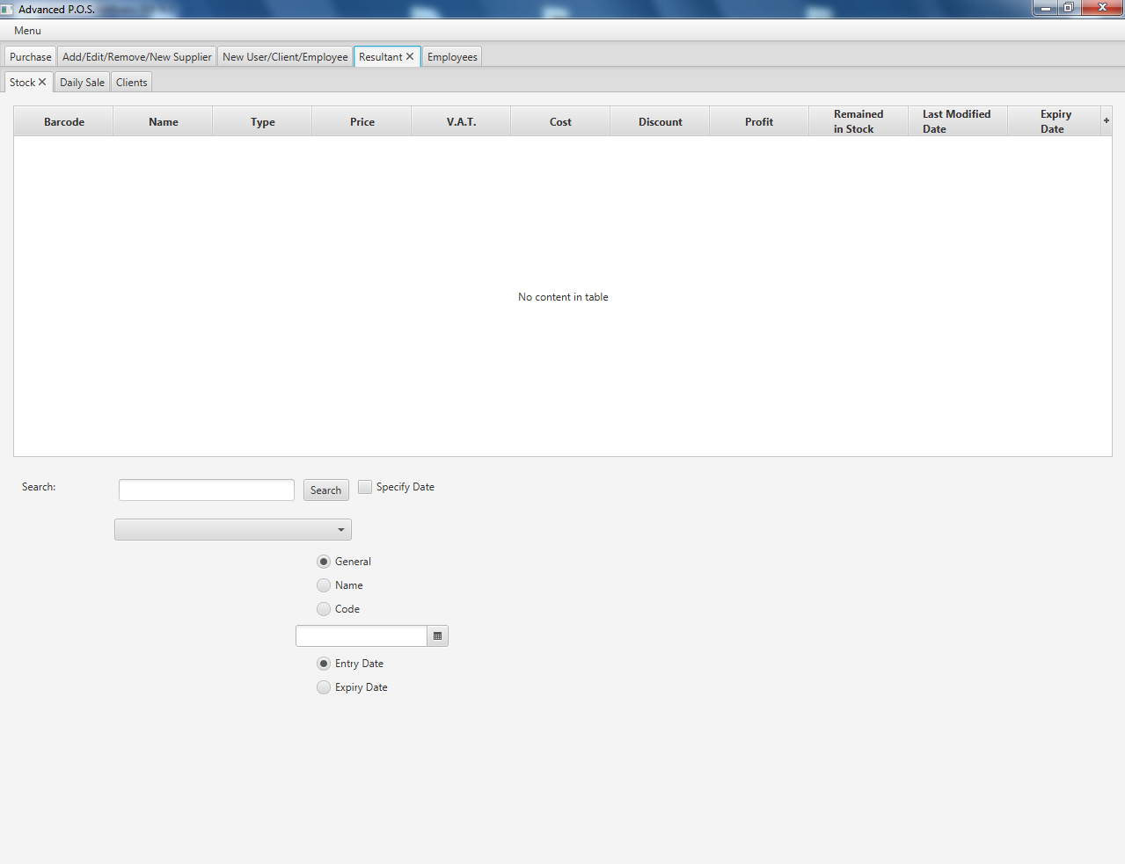

This tab is used to search the stock products for the user to know what products he/she still have and what should he/she re-add (although the menu has a checkbox alert that can be checked so the P.O.S. could alert the user for the products with less than 10 items in the stock) with all other information needed for each product alone.

The user can specify to search due to the product’s name or code, even he/she can specify a specific date to search.

1. Daily Sale tab:

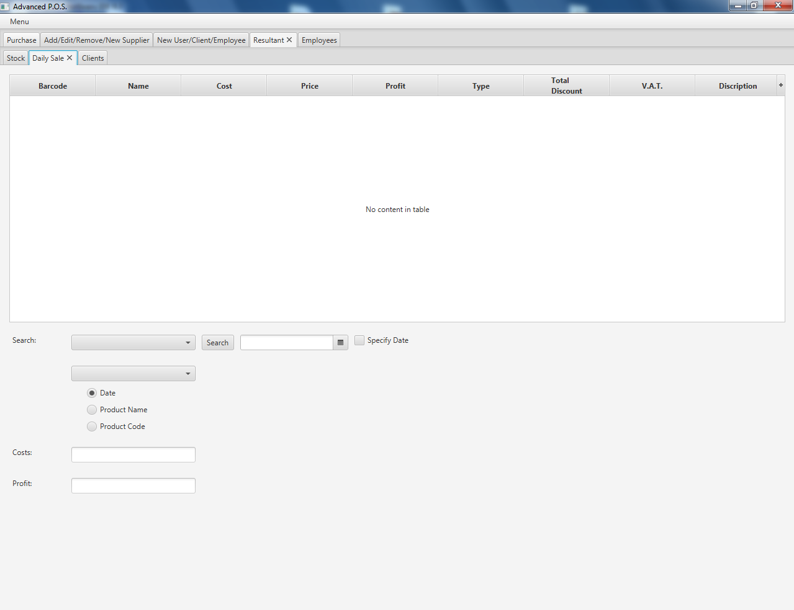

This tab is used search for sold product day by day.

The user can search for the date he/she wants to know, or even search for a specific product by its name or Barcode in general or due to specific date.

1. Clients tab:

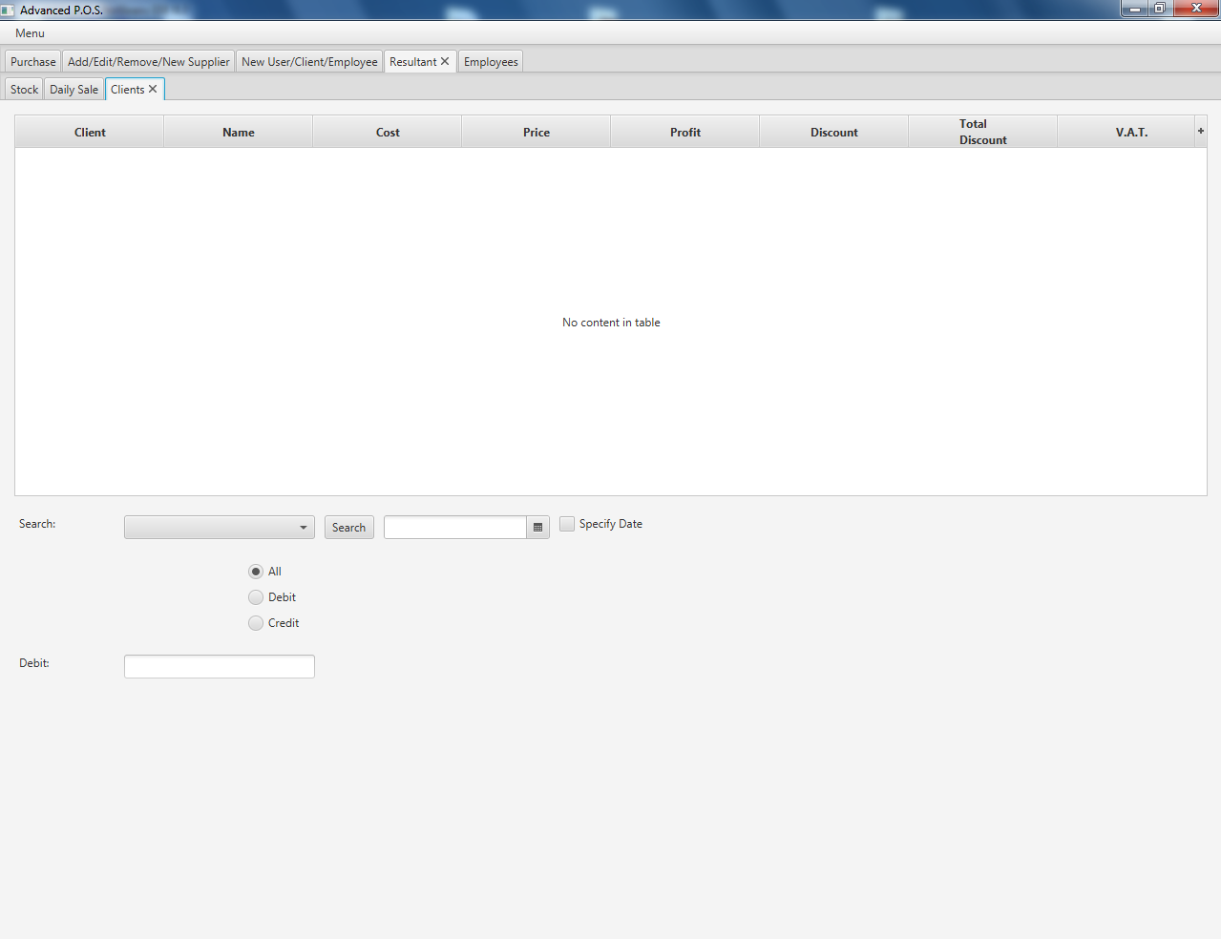

This tab is used to search a specific client by selecting his/her name from the combo box and searching for what he/she bought in general or due to the way he paid or want to pay (Cash or debit). Moreover, the user can specify a specific date to search.

After all, the system will calculate the amount of debit in this client account.